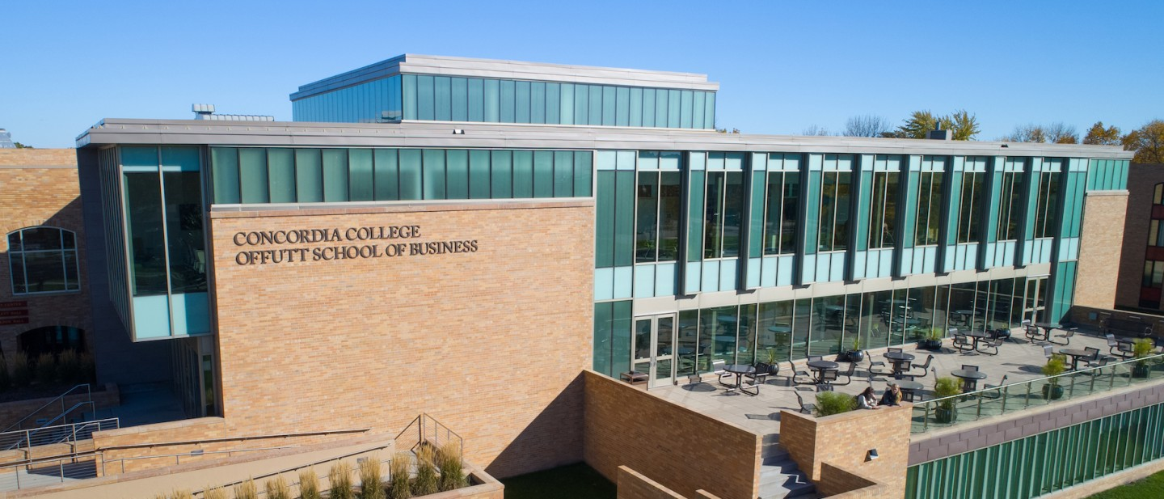

Project Plan

|  |
| --- |
| Cashier Simulator |

|  |  |
| --- | --- |
| Course | **CSC 225 – Fundamental Structures** |
|  | |
| Team Name | **May We Succeed** |
|  |  |
| Team Members | **Abigail Mueller** |
|  | **Hannah Christensen** |
|  | **Zackery Snyder** |
|  | **Akua Adjei** |

|  |
| --- |
| Executive Summary |
| Your executive summary should resemble an elevator pitch: your motivation is to quickly persuade a decision maker to get involved in your project.  What is the purpose of your project? What problem(s) does it address?  Why is your project important? Why is it relevant?  **The purpose of our project is to create an interactive simulator that conceivably teaches adolescents and adults how to handle currency and card transactions. With a rise in open job positions and a constant influx in adolescents who need a job, understanding this concept is incredibly important. This allows for crucial training in which a job may not supply, or lack to inform, to a new cashier employee who has not dealt with cash registers before or who are experiencing their first ever job. Our project is a safe, stress-free place for these individuals, so they do not have to feel anxious about their new, or first, job position.** |

|  |
| --- |
| Timeline |

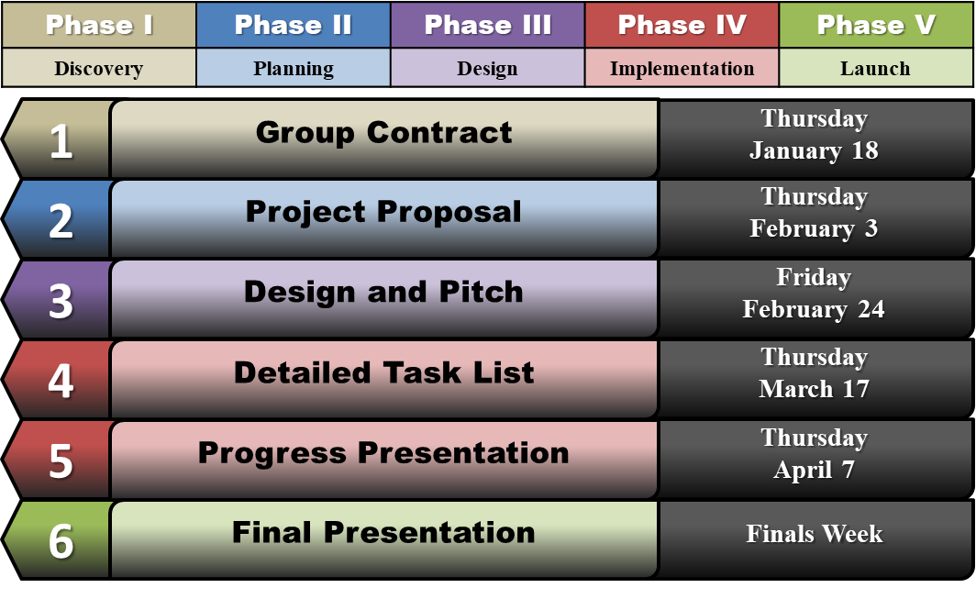

|  |  |  |
| --- | --- | --- |
| Milestone Summary | | |
| **Milestone 1** | **Group Contract** |  |
| **Item** | **Description** | **Date Completed** |
| **Purpose** | **Create a final project team** | **1/18/2022** |
| **Summary** | Self-organize into groups of 3-4 students for working together on the semester project.  All team members will need to complete the group contract and agree to its terms, holding each other accountable for contributing to the final project throughout the semester. | **1/18/2022** |
| **Task M1A – Team Member Names** | List all team members with full (first and last) names on the group contract document | **1/18/2022** |
| **Task M1B – Team Name** | Come up with a name for the group/team to be addressed as during presentations; list the name on the group contract document | **1/18/2022** |
| **Task M1C – Weekly Meeting Time** | Block off an hour of time once per week when all team members could regularly meet as necessary throughout the semester; list the time in the group contract document | **1/18/2022** |
| **Task M1D – Signatures** | Each team member signs the group contract document (this may be a digital signature or initials) | **1/18/2022** |
| **Task M1E – Planning Document** | Complete the cover page of the planning document, fill in the date each milestone task was completed in the milestone summary, and detail the additional milestone activities in the Milestone Summary section (insert new rows into the table). | **1/18/2022** |
| **Milestone 2** | **Project Proposal** |  |
| **Item** | **Description** | **Date Completed** |
| **Purpose** | **Determine final project topic** | **1/31/2022** |
| **Summary** | As a group, choose a topic all team members want to work on; discuss potential ideas and come to a group consensus what your project will be and why it is important. | **1/31/2022** |
| **Task M2A – Project Proposal Document** | Complete the project proposal document | **2/2/2022** |
| **Task M2B – Presentation** | Present the project proposal to the class | **2/3/2022** |
| **Task M2C – Planning Document** | Complete the executive summary section of the planning document, fill in the date each milestone task was completed in the milestone summary, and detail the additional milestone activities in the Milestone Summary section (insert new rows into the table). | **2/2/2022** |
| **Milestone 3** | **Design and Pitch** |  |
| **Item** | **Description** | **Date Completed** |
| **Purpose** | **Create a general look-and-feel for your project, present your project to the class** | **2/24/2022** |
| **Summary** | Determine how you want your final project deliverables to look, including color scheme, graphics/images, and placement and layout of major components (e.g. buttons, input fields, data, instructions, etc.).  Armed with your project proposal and design mockups, show the class what you plan to accomplish with your project. Think of the class as potential investors or contributors; why should they care about your project? | 2/7/2022  2/24/2022 |
| **Task M3A – Major Components** | Create a list of major components that will be included in your project (e.g. input/output, images, instructions, etc.) | 2/23/2022 |
| **Task M3B – Color Scheme** | Create a color scheme for your project for a consistent design | 2/23/2022 |
| **Task M3C – Design Mockups** | Create design mockups (use lorem ipsum filler text, at least basic boxes/shapes if not actual design) to show the planned layout of project deliverables, including any major pages/screens that will be included in the final project | 2/23/2022 |
| **Task M3D – Presentation** | Pitch the project to the class | 2/24/2022 |
| **Task M3D – Google Slides** | Creating the Introduction, Work performed so far, What has gone well, Challenges, Plan for remaining work, and Conclusion sections of the presentation | 2/23/2022 (Zack S.) |
| **Task M3E – Planning Document** | Include screenshots of all design mockups, list of components (labeled for easy identification), screenshots of the project pitch presentation, fill in the date each milestone task was completed in the milestone summary, and detail the additional milestone activities in the Milestone Summary section (insert new rows into the table). | 2/23/2022 |
| **Task M3D – Design Mockup #1** |  | 2/23/2022 (Zack S.)  [Image Address](https://static.turbosquid.com/Preview/2020/01/22__11_56_18/ToonCashRegister.jpgDA6CA6EA-F011-4342-B5BE-6BEB662E6ACCLarge.jpg)  [Website Address](https://www.turbosquid.com/3d-models/cartoon-cash-register-3d-1499171) |
| **Task M3D – Design Mockup #2** |  | 2/23/2022 (Zack S.) |
| **Task M3D – Design Mockup #3** |  | 2/23/2022 |
| **Task M3D – Design Mockup #4** |  | 2/23/2022 |
| **Task M3D – Design Mockup #5** |  | 2/23/2022 |
| **Task M3D – Design Mockup #6** |  | 2/23/2022 |
| **Task M3D – Component ID Table #1** |  | 2/23/2022  (Zack S.) |
| **Task M3D – Component ID Table #2** |  | 2/23/2022  (Zack S.) |
| **Task M3D – Component ID Table #3** |  | 2/23/2022 |
| **Milestone 4** | **Detailed Task List** |  |
| **Item** | **Description** | **Date Completed** |
| **Purpose** | **Plan the remaining tasks required to complete the project** | **3/19/2022** |
| **Summary** | As a team, figure out what needs to happen in order to take the project from its current design and planning stage through implementation to completion.  Break down each major component of the project to estimate how much work you think it will take to complete, and what detailed tasks/actions will need to be performed for each. | 3/19/2022 |
| **Task M4AS – Task 1.1** | Create array list of items |  |
| **Task M4AS – Task 1.2** | JFrame |  |
| **Task M4AS – Task 1.3** | Create separate classes |  |
| **Task M4AS – Task 2.1** | Create Methods for each class |  |
| **Task M4AS – Task 2,2** | Create Properties for each class |  |
| **Task M4AS – Task 2.3** | Create main Constructors for each class |  |
| **Task M4AS – Task 3.1** | Begin writing more detailed constructors of the math equations |  |
| **Task M4AS – Task 3.2** | Begin writing more detailed constructors of the items chosen by customer/user input |  |
| **Task M4AS – Task 3.3** | Polishing work |  |
| **Task M4A – Gantt Chart** | Create a Gantt chart showing a detailed task breakdown with expected due dates and assigned team members | 3/19/2022 |
| **Task M4B – Presentation** | Present your Gantt chart and task list to the class | 3/22/2022 |
| **Task M4C – Planning Document** | Include a screenshot of the Gantt chart, fill in the date each milestone task was completed in the milestone summary, and detail the additional milestone activities in the Milestone Summary section (insert new rows into the table). | 3/19/2022 |
| **Milestone 5** | **Progress Presentation** |  |
| **Item** | **Description** | **Date Completed** |
| **Purpose** | **Provide the class with a project status update** |  |
| **Summary** | Show the class (client) what work has been completed toward the final project deliverables. |  |
| **Task M5A – Presentation** | Present your work progress to the class |  |
| **Task M5B – Planning Document** | Include screenshots of your presentation, fill in the date each milestone task was completed in the milestone summary, and detail the additional milestone activities in the Milestone Summary section (insert new rows into the table). |  |
| **Milestone 6** | **Final Presentation** |  |
| **Item** | **Description** | **Date Completed** |
| **Purpose** | **Show your completed project to the class** |  |
| **Summary** | Share your hard work over the course of the semester with the class. |  |
| **Task M6A – Presentation** | Present your completed project to the class |  |
| **Task M6B – Planning Document** | Include screenshots of your final project deliverables and presentation, fill in the date each milestone task was completed in the milestone summary, and detail the additional milestone activities in the Milestone Summary section (insert new rows into the table). |  |

|  |  |
| --- | --- |
| Resource List | |
| **Resource Name** | Cash Register Image |
| **URL** | **https://www.turbosquid.com/3d-models/cartoon-cash-register-3d-1499171** |
| **Date Accessed** | **2/23/2022** |
| **Notes** | Image used for the main menu screen of the game – an image of a cartoon cash register |
| **Resource Name** |  |
| **URL** |  |
| **Date Accessed** |  |
| **Notes** |  |
| **Resource Name** |  |
| **URL** |  |
| **Date Accessed** |  |
| **Notes** |  |
| **Resource Name** |  |
| **URL** |  |
| **Date Accessed** |  |
| **Notes** |  |
| **Resource Name** |  |
| **URL** |  |
| **Date Accessed** |  |
| **Notes** |  |
| **Resource Name** |  |
| **URL** |  |
| **Date Accessed** |  |
| **Notes** |  |